AINT 253 Design Process (Coursework 1B)

By Dominic Reader

Design Challenge Two

For Design Challenge Two the specification was:

“You will interview a fellow student. Information gathered will be used to create a bedroom scene that reflects this student. Combining visual, audio, and interactive elements for the final visualization.”

From reading the specification I will need to do a few things which include:

* Interview a fellow student
* Create a bedroom scene
* Combination of assets
* Visual, Audio, Interactive

First, I had to hold the interview to decide what had to go into the room as well as its properties. The interview questions and answers are below:

What Is the first thing you notice when you walk in to the bedroom?

Desk Table - Medium size - Wooden matte colour

Window - largeish - same size width - .7 meter height

Bed - Corner - Single

Double Wardrobe

How large is the room?

Medium size, room to walk around

What colour are the walls?

Enable light colour

What type of flooring?

Carpet - Black/Grey gradient carpet

What is on the walls?

Shelves - double unit - wooden (light) - screwed in

Audio for the room

What can you hear (Ambient Noise)?

Traffic, People walking past, rain if raining

What sounds as you walk around (Walking Noise)?

Footsteps

From these questions I had elements to focus on and create to put into the room. Planning these elements individually would give me a reference to the creation of them, to plan these I created mood boards on RealTimeBoards which are shown below:

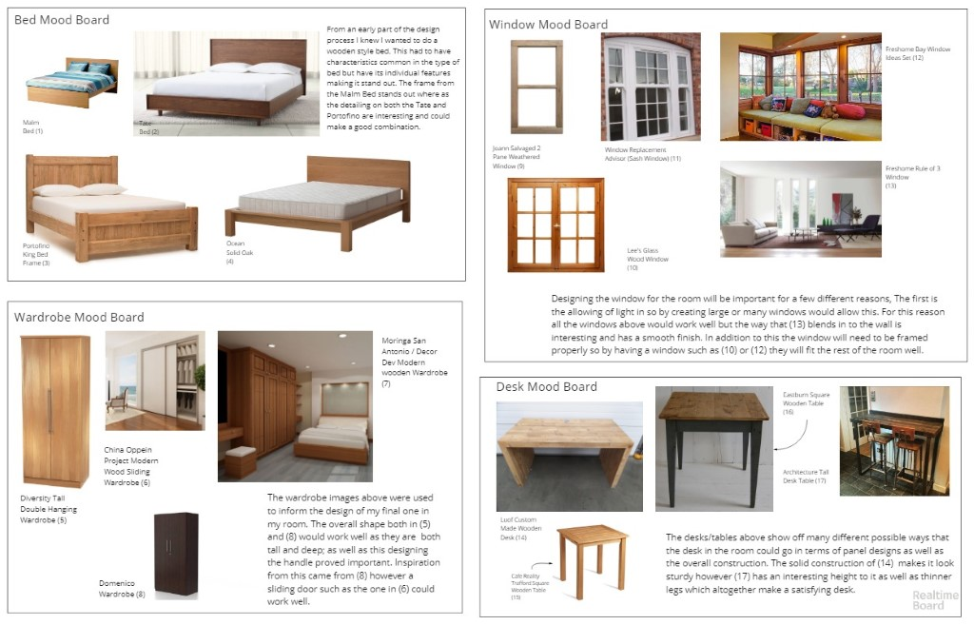

Link to RealTimeBoard (https://realtimeboard.com/app/board/o9J_kykLZJ8=/)

After planning the assets I would create, I started exploring the process of doing so in 3DS Max. Initially finding it very hard to create assets I had to go through different iterations to find what would work. In the room the main interactivity is with the wardrobe; this involves the opening and closing of the doors which is shown to the user from a UI prompt in the top left in the screen. Making sure the doors both opened and closed smoothly was important as if they did not do this properly it would’ve made a bad experience overall.

Next deciding on the colours of the room was a tough decision as it would set the scene as well influence how the lighting in the room would reflect of the walls and objects in the room. Both the table and bed have the same texture which has a reflective element to it which catches the light well and shows it off. The wardrobe has a different shade which allows light to react it differently which creates different focus points for the user to look at.